CS2023 - Data Structures and Algorithms

In-class Lab Exercise - Week 8

May 2, 2023

Name: A. C. Pasqual

Index No. : 200445V

**Terminal Output (Input is a random array)**

**Sample Max Heap for the input**

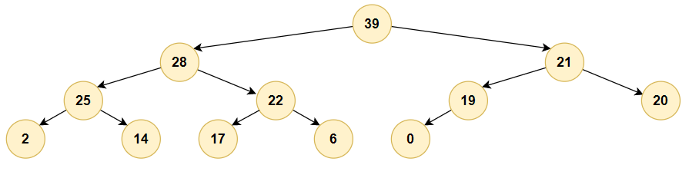

Time complexity of Heap Sort

* Heapify operation - O(logn) where n is the number of nodes in the subtree
* Build heap operation (perform heapify for all nodes) – O(n)
* Extract top of the heap – O(logn)
* Extract top of the heap n times – O(nlogn)

Total time complexity = O(n) + O(nlogn) = **O(nlogn)**

Complete GitHub repository for code: <https://github.com/Anuki16/cs2023-data-structures-algorithms>